**NIPWG 6-11.2**

## Paper for Consideration by NIPWG

## STM - Baltic Navigational Warning service

|  |  |
| --- | --- |
| ***Submitted by:*** | Sweden |
| ***Executive Summary:*** | Information paper |
| ***Related Documents:*** | HGDM 2/5 - *Best practice for writing guidelines for a maritime service –*  *experiences from the STM project* |
| ***Related Projects:*** | S-124 CG |

## Introduction / Background

STM* Validation Project is a major e-navigation project co-financed by the European Union Connecting European Facilities Program (CEF) and coordinated by the Swedish Maritime Administration. STM has more than 50 partners and is currently finalizing its validation phase with 300 ships, 13 ports and 5 shore centers (Vessel Traffic Center, Joint Rescue Coordination Center and Fleet Operating Centers) equipped with STM functionality exchanging information.

One of the services that has been developed during the project is the Baltic Navigational Warning service. The service provides safety notices to ships in S-124 format and the STM Validation Project will serve as one of the testbeds to validate the S-124 product specification developed by the S-124 CG.

The Baltic Navigational Warning service provides the following navigational safety notices:

• Coastal warnings - Navigational warnings that apply to open waters are classified as coastal. The same information is currently transmitted on NAVTEX.

• Local warnings for Swedish & Finnish waters - Warnings that apply only to waters in the archipelago are regarded as local. Today transmitted on VHF.

• Temporary and Preliminary Notices to Mariners for Swedish waters

*T&P Notices to Mariners are not originally intended to be included in the S-124 standard, but is tested as a part of the Baltic Navigational Warning service.*

The service is initiated when a ship shares its Voyage Plan (VP) with the Baltic Navigational Warning service. In response, the Baltic Navigational Warning service initially provides the ship with all valid safety notices in the concerned area(s), see Figure 1, and then continuously provides all updates.

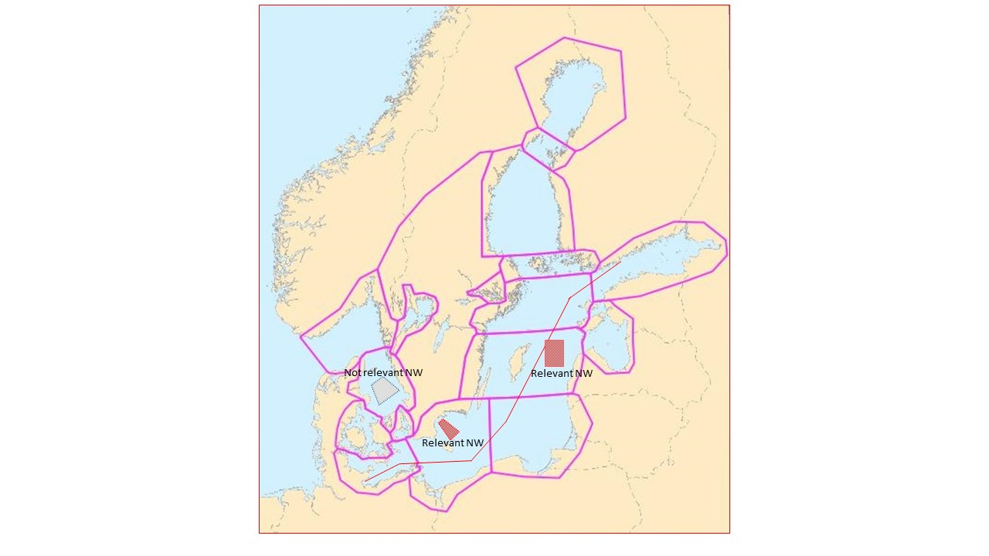

Figure 1, Example of relevant notices based on ships Voyage Plan and MSI-area

Notices that are within the MSI-area(s) that the route crosses are deemed as relevant and returned to the ship. Notices in other MSI-areas will not be returned.

When a ship has left the service coverage area, the Baltic Navigational Warning service stops sending updates to the ship.

**The Baltic Navigational Warning service does not relieve Masters of the requirement to receive Navigational Warnings via IMO/IHO approved broadcast systems**

## Analysis/Discussion

As new technology develops and e-navigation moves forward, it is a great opportunity to be able to use projects like the projects within the scope of STM to test new ways to distribute and receive information needed by the mariner.

It is done in a controlled environment and gives both service providers and service consumers a good “learning by doing” experience and it is of great value in developing new product specifications.

## Recommendations

Continue to monitor and work together with e-navigation projects.

## Justification and Impacts

A lot of MS are dealing with insufficient resources to be able to contribute in the development of new product specifications. When standardization bodies work together with e-navigation projects both will benefit from it. There are external funding available in such projects and thus give the MS possibilities to strengthen their resources needed and the projects are dependent on the needed competence available at for example a HO.

## Action Required of NIPWG

The NIPWG is invited to:

Endorse the development of services like the Baltic Navigational Warning service